Pupil Progress and Achievement Information -
Key Stage 4

(2017 / 2018)
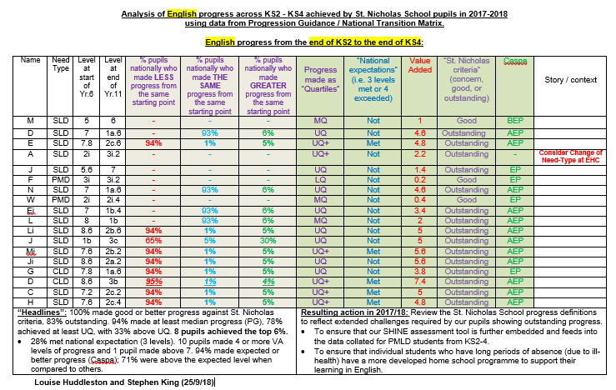
Headline Results
English
- 100% made good or better progress against St. Nicholas criteria and 83% outstanding.
- 94% made at least median progress (PG), 78% achieved at least UQ, with 33% above UQ. 8 pupils achieved the top 6%.
- 28% met national expectation (3 levels). 10 pupils made 4 or more VA levels of progress and 1 pupil made above 7. 94% made expected or better progress (Caspa); 71% were above the expected level when compared to others.
Resulting action in 2018/19:
- Review the St. Nicholas School progress definitions to reflect extended challenges required by our pupils showing outstanding progress.
- To ensure that our SHINE assessment tool is further embedded and feeds into the data collated for PMLD students from KS2-4.
- To ensure that individual students who have long periods of absence (due to ill-health) have a more developed home school programme to support their learning in English.
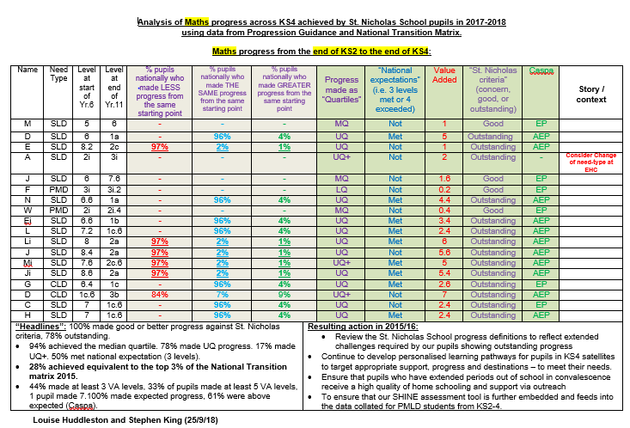
Maths
“Headlines”:
- 100% made good or better progress against St. Nicholas criteria, 78% outstanding.
- 94% achieved the median quartile. 78% made UQ progress. 17% made UQ+. 50% met national expectation (3 levels).
- 28% achieved equivalent to the top 3% of the National Transition matrix 2015.
- 44% made at least 3 VA levels, 33% of pupils made at least 5 VA levels, 1 pupil made 7.100% made expected progress, 61% were above expected (Caspa).
Resulting action in 2015/16:
- Review the St. Nicholas School progress definitions to reflect extended challenges required by our pupils showing outstanding progress
- Continue to develop personalised learning pathways for pupils in KS4 satellites to target appropriate support, progress and destinations – to meet their needs.
- Ensure that pupils who have extended periods out of school in convalescence receive a high quality of home schooling and support via outreach
- To ensure that our SHINE assessment tool is further embedded and feeds into the data collated for PMLD students from KS2-4.
Science
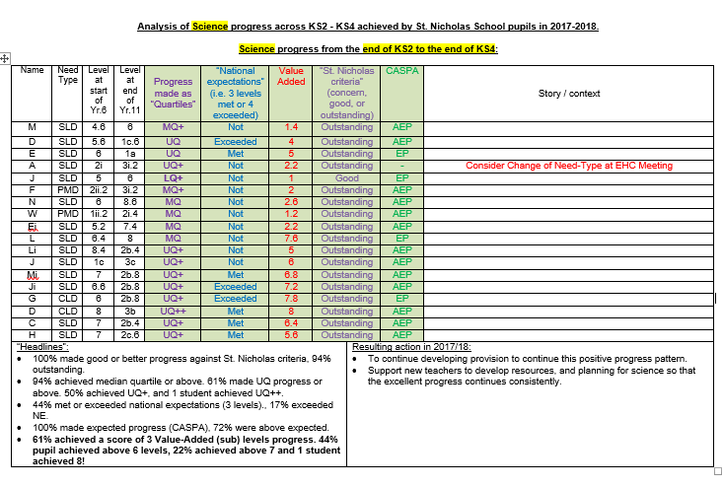
“Headlines”:
- 100% made good or better progress against St. Nicholas criteria, 94% outstanding.
- 94% achieved median quartile or above. 61% made UQ progress or above. 50% achieved UQ+, and 1 student achieved UQ++.
- 44% met or exceeded national expectations (3 levels)., 17% exceeded NE.
- 100% made expected progress (CASPA), 72% were above expected.
61% achieved a score of 3 Value-Added (sub) levels progress. 44% pupil achieved above 6 levels, 22% achieved above 7 and 1 student achieved 8!

Resulting action in 2017/18:
- To continue developing provision to continue this positive progress pattern.
- Support new teachers to develop resources, and planning for science so that the excellent progress continues consistently.

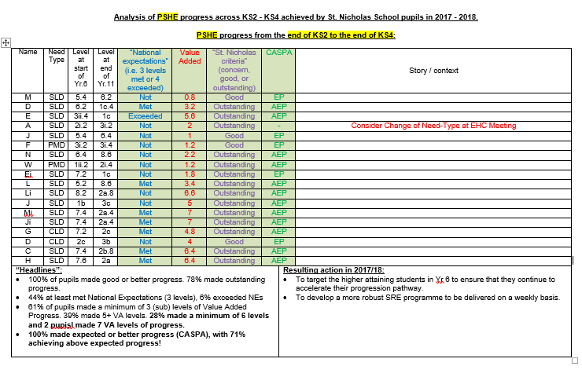
PSHE
Headlines”:
- 100% of pupils made good or better progress. 78% made outstanding progress.
- 44% at least met National Expectations (3 levels), 6% exceeded NEs
- 61% of pupils made a minimum of 3 (sub) levels of Value Added Progress. 39% made 5+ VA levels. 28% made a minimum of 6 levels and 2 pupisl made 7 VA levels of progress.
100% made expected or better progress (CASPA), with 71% achieving above expected progress!

Resulting action in 2017/18:
- To target the higher attaining students in Yr 6 to ensure that they continue to accelerate their progression pathway.
- To develop a more robust SRE programme to be delivered on a weekly basis.

Computing
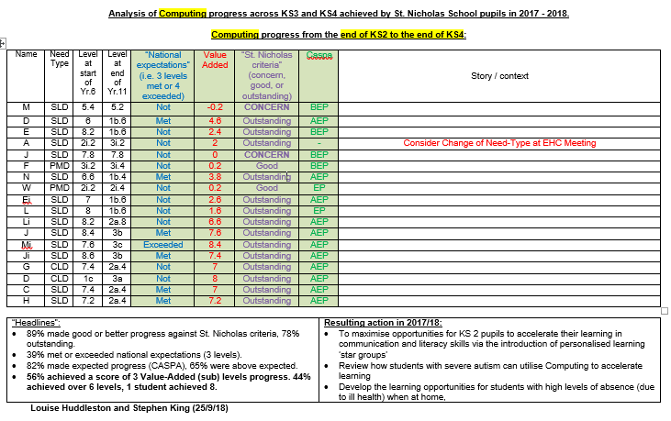
Headlines”:
- 89% made good or better progress against St. Nicholas criteria, 78% outstanding.
- 39% met or exceeded national expectations (3 levels).
- 82% made expected progress (CASPA), 65% were above expected.
56% achieved a score of 3 Value-Added (sub) levels progress. 44% achieved over 6 levels, 1 student achieved 8.
Resulting action in 2017/18:
- To maximise opportunities for KS2 pupils to accelerate their learning in communication and literacy skills via the introduction of personalised learning ‘star groups’
- Review how students with severe autism can utilise Computing to accelerate learning
- Develop the learning opportunities for students with high levels of absence (due to ill health) when at home
- Ensure that the department has appropriate access to required equipment

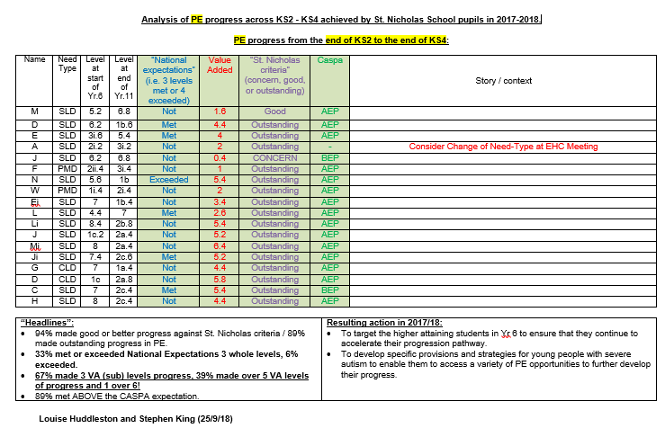
PE
“Headlines”:
- 94% made good or better progress against St. Nicholas criteria / 89% made outstanding progress in PE.
- 33% met or exceeded National Expectations 3 whole levels, 6% exceeded.
- 67% made 3 VA (sub) levels progress, 39% made over 5 VA levels of progress and 1 over 6!
- 89% met ABOVE the CASPA expectation.
Resulting action in 2017/18:
- To target the higher attaining students in Yr 6 to ensure that they continue to accelerate their progression pathway.
- To develop specific provisions and strategies for young people with severe autism to enable them to access a variety of PE opportunities to further develop their progress.

